FITNESS TO PRACTISE WHAT YOU NEED TO KNOW
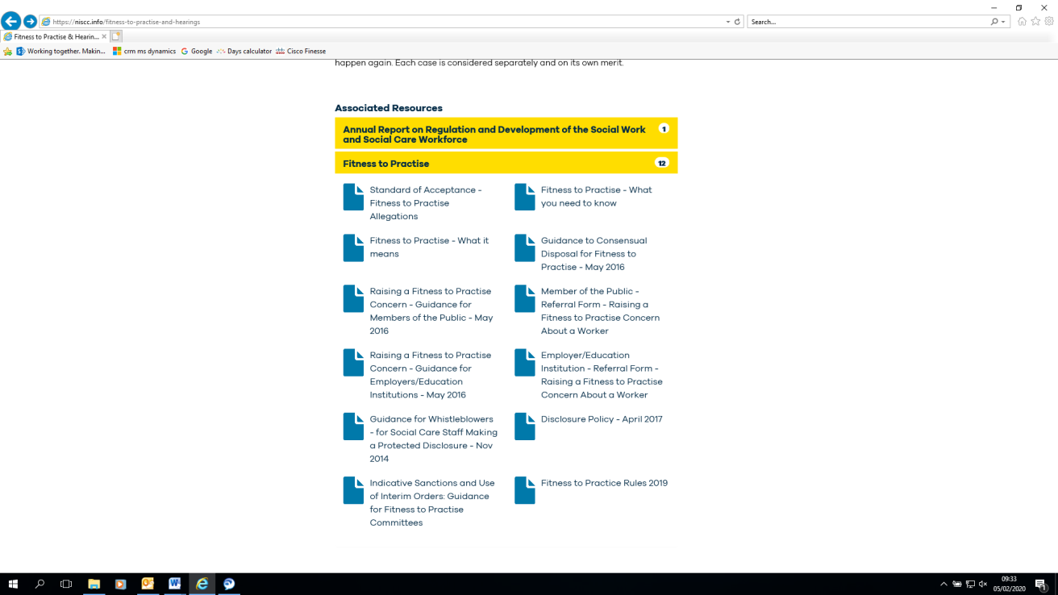
*Accessed 05.02.20.

Document description
This document is an 11 page guide to the basics of what an individual needs to know about the Fitness to Practise process.
This document contains the old branding.

The content of this document
See next 11 pages for the text of the original document as presented in the original style.

Fitness To Practise

WHAT YOU NEED
TO KNOW

May 2016

Northern Ireland Social Care Council
7th Floor, Millennium House
19-25 Great Victoria Street
Belfast
BT2 7AQ
Tel: 028 95 362 325
E-mail: info@niscc.hscni.net
Website: www.niscc.info

1
This booklet provides a brief overview of the Northern Ireland Social Care Council’s fitness to practise process. It is aimed at all those involved in the process and anyone with an interest in it. It outlines the different stages and the possible outcomes at each stage.

Contents

Fitness to Practise – what does it mean?

3
Overview of fitness to practise process

4-6
Consideration of an allegation by Officers
Consensual disposals
- Warnings
- Undertakings
- Removal by Agreement
Direct Transfer to a Fitness to Practise Committee

7
Consideration by a Preliminary Proceedings Committee
Interim Orders

8
Fitness to Practise Committee
Health matters

9
Appeals to the Care Tribunal
Restoration Committee
Membership of Committees
Additional guidance and documents
Getting professional or legal advice and representation
Contacting NISCC

10
The fitness to practise process

2

Fitness To Practise

An overview of the fitness to practise process

NISCC’s fitness to practise and hearings process is governed by the
NISCC Fitness to Practise Rules 2016. This process applies to any
Registrant against whom NISCC has received an allegation. In each
instance, NISCC will only take a matter through its fitness to
practise process if it considers that there is a real prospect of a
finding of impaired fitness to practise. For more information on
what ‘fitness to practise’ means, please refer to the leaflet Fitness
to Practise – what it means. Cases referred to NISCC may be
closed at various stages in the fitness to practise process sonot all
Registrants will go through all of the stages outlined in this
booklet. It will depend on the particular nature of their case.

3
Fitness To Practise Consideration of an allegation by officers

Upon receipt of an allegation about a Registrant, an assessment will be made about whether the information is appropriate for consideration by NISCC (See Standard of Acceptance). If it is not, no further action is taken.

If the allegation is appropriate for consideration, the Registrant is notified and provided with the opportunity to respond and an investigation is undertaken. This may include obtaining evidence from, for example, the person making the allegation, the Registrant’s employer, witnesses or the Police. Following this, the case is discussed at case conference where the information
obtained is evaluated and the level of risk is assessed to decide whether there is a real prospect of a finding of impaired fitness to practise. One of the following decisions is then made:

- to close the case;
- to close the case and issue a written reminder to the Registrant about their responsibilities under the Standards of Conduct and Practice;
- to dispose of the case by consensual means through either issuing a warning, agreeing undertakings with the Registrant, or Removal by Agreement;
- to forward the case for consideration
by the Preliminary Proceedings Committee;
- to transfer the case directly to a Fitness to Practise Committee.

Cases that are closed at this stage may include those involving some types of cautions and minor criminal convictions. Examples of these would be motoring offences not involving a service user; where it is considered that the circumstances leading to the caution or conviction do not amount to impaired fitness to practise; or where it is considered that the employer has adequately dealt with the matter, for example, by putting in place measures for
specific training, mentoring or extra supervision.

Close the case and issue a written reminder
This is a written reminder sent to the Registrant about their responsibilities under the Standards of Conduct and Practice where a decision is taken that no further action should be undertaken in relation to an allegation. The Registrant is also informed that this information may be reconsidered in the light of any further allegation received by NISCC.

Further investigation
Further investigation of the matter may be required where it is considered that there is insufficient information / evidence currently available to enable a decision to be made regarding which way to proceed with the case; for example if NISCC is waiting for information from the Police, Higher Education Institution or Employer.

Consensual disposal
NISCC can in certain circumstances, dispose of cases by consent. Disposal by consent is a means by which NISCC and the Registrant concerned, can seek to conclude a case without the need for a contested hearing, by agreeing a sanction of the kind which a Committee would have been likely to make in any event. This allows for more efficient use of resources and also for matters to be concluded more quickly.

NISCC will only consider resolving a case by consent following a robust risk assessment process and where the Registrant is willing to admit the allegation in full.

All consensual disposals will be published for the period they apply.

NISCC may dispose of a case by means of:

- agreeing Undertakings with a Registrant
- issuing a Warning
- granting Removal from the Register by agreement

4

Fitness To Practise Consideration of an allegation by officers

Further investigation
A Council level warning allows a case to be
dealt with without the need for a hearing and is likely to be most appropriate for those cases where it is anticipated that a Fitness to Practise Committee would impose a warning if the case was to progress to a full hearing. A warning can be imposed for up to five years. It does not restrict the Registrant’s ability to practise.

If the Registrant does not agree to the warning, the case will proceed to the Preliminary Proceedings Committee which will deal with the case in the same way as any other case.

Where the Registrant fails to engage with NISCC within the specified timescale, the Council will proceed to impose a warning. In this circumstance, the Registrant will have the right to appeal the decision to the Care Tribunal.

Undertakings
An ‘undertaking’ is an agreement between
the Registrant and NISCC in relation to work practices. It enables a Registrant to continue working and is agreed between the Registrant and NISCC without referral to a Committee.

NISCC will agree an undertaking(s) with a Registrant if it considers that a case might be appropriate for disposal by this means. Examples of undertakings may include an agreement to undertake additional training or to attend a health related treatment programme.

For an undertaking(s) to be agreed, the
Registrant will have to:

- admit the allegation(s);
- admit that the actions amount to impaired fitness to practise; and
- confirm agreement to comply with the undertaking(s).

If the Registrant does not agree to the undertaking(s), the case will be referred to a Preliminary Proceedings Committee (PPC).

The PPC will deal with the case in the same way as any other case i.e. its role will not simply be to determine whether the undertaking(s) should be imposed.

An undertaking(s) will not be time bound however the Registrant may apply for early release from the undertaking if they consider that their fitness to practise is no longer impaired.

If the Registrant fails to meet the undertaking(s), the matter will be referred to a PPC.

5

Fitness To Practise Consideration of an allegation by officers

Removal by agreement
Through this process, a Registrant can apply to be removed from the Register without being referred to a Committee. The decision to agree to the application is made at a Case Conference. Applying for removal by agreement does not mean that a Registrant has the right to be removed, but it enables NISCC to agree to removal in an appropriate case. The decision whether to agree the application is made taking into account whether the allegation involves exceptional public interest issues. If it is considered that it does, the application will be refused.

If it is not agreed that a Registrant can be removed by this process, then the Registrant will be referred to a Preliminary Proceedings Committee or directly to a Fitness to Practise Committee.

If it is agreed that a Registrant can be removed by this process, correspondence will take place between NISCC and the Registrant that will result in the Registrant:

- admitting the allegation/s against them;
- signing an agreed statement of facts.
This means admitting to the agreed established facts. The document contains the details and evidence that establishes the facts of the allegation/s;
- admitting that his / her fitness to practise is impaired due to the matters set out in the agreed statement of facts;
- confirming in writing that he / she understands that they will be removed from the Register; they cannot apply for restoration until five years from the date they are removed; that NISCC will inform the person making the allegation and the employer or university; that the Disclosure and Barring Service and another regulatory body may be informed; and that the decision will be made public.

NISCC will publicise the outcome of a removal under this process on its website along with the details of the allegation/s and the statement of facts.

If a Registrant is removed through this process, he/she will not be able to apply to be restored to the Register until five years following their removal. To do this, they will have to apply to a Restoration Committee and prove that they should be restored to the Register.

Direct Transfer to a Fitness to Practise Committee
A case may be referred directly to a Fitness to Practise Committee where the findings of fact of a regulatory body (such as the Nursing and Midwifery Council) or the Disclosure and Barring Service can be used as evidence that the facts have been found, or where the allegation is based upon a caution or conviction for a criminal offence in any UK Court, or where the allegation is based on a caution or conviction for an offence in another country, which, if committed in the UK, would constitute a criminal offence.

6

Fitness To Practise Consideration by a Preliminary Proceedings Committee

Consideration by a Preliminary Proceedings Committee

Any case where it is considered that an
independent perspective is required to reach a decision on whether there is a real prospect of a finding of impaired fitness to practise, and all cases where it is considered that an Interim Suspension Order or an Interim Conditions of Practice Order should be imposed, will be referred to a Preliminary Proceedings Committee. This Committee can:

- close a case, with no further action;
- direct further investigation is required;
- issue a written reminder;
- refer back to the Council to pursue a consensual disposal;
- suspend a Registrant from the Register for a set period whilst an investigation is undertaken (Interim Suspension Order);
- impose interim conditions on a Registrant whilst an investigation is undertaken (Interim Conditions of Practice Order); or
- refer a case to a Fitness to Practise
Committee.

All Interim Suspension Orders and Interim Conditions of Practice Orders are placed on NISCC’s website.

Close the case with no further action
The Committee may decide, based on the information it receives from NISCC and the Registrant, that there is no case to answer and close the case.

Interim Suspension Order
If NISCC considers that the information received shows that a Registrant may pose a risk to the public, colleagues, or service users, or that it is in the public interest, or in the interest of a Registrant, it can recommend that the Committee imposes an Interim Suspension Order (ISO). An ISO suspends a registered worker from the Register on a temporary basis while the case is being investigated.

It means that a Registrant will be unable to work in a role that requires Registration
whilst the Order is in place. It means that, a registered social worker will be unable to work as or call himself / herself a registered social worker or work in a role which requires registration while the Order is active.

If a Registrant is a social care manager or a social care worker, it means that he /she will not be able to work in a role which requires a registrant to be registered with NISCC while the Order is active. If the Registrant is a social work student, it will mean that they are suspended from their course while the Order is active.

An ISO may be set for any length of time (but only up to six months initially), with set review periods during its term, and cannot be imposed for more than two years in total except in exceptional circumstances, for example, where a criminal conviction case is on-going.

IInterim Conditions of Practise Order
An Interim Conditions of Practice Order (ICPO) is an Order that temporarily places conditions upon a Registrant’s registration while the investigation is taking place. A Registrant will be able to continue working while the ICPO is in place, however, there will be conditions on his / her practice.

The type of conditions that could be
imposed may be:

- to undertake specific training within a defined period and provide evidence of the successful completion of that training to NISCC;
- to provide NISCC with a monthly report signed by his / her employer confirming that he / she is complying with a relevant requirement , e.g. not undertaking a particular activity without supervision; adhering to employer policies and procedures.

An ICPO may be set for any length of time (but only up to six months initially), with set review periods during its term, and cannot be imposed for more than two years in total.

Refer a case to a Fitness to Practise Committee
The Committee may decide, based on the information from NISCC and the Registrant, that the Registrant’s fitness to practise may be impaired and that it should therefore be referred to a Fitness to Practise Committee to make a final decision on the matter.

7
Fitness To Practise Fitness To Practise Committee

Fitness to Practise Committee

A Fitness to Practise Committee, which generally sits in public, will consider the allegations against the Registrant and decide whether the Registrant’s fitness to practise is impaired. If the Committee considers that the Registrant’s mental or physical ill health was a cause or substantial contributor to the alleged impaired fitness to practise, it will sit in private. The Committee will be able to:

- close a case, with no further action
(as above);
- issue a written reminder (as above);
- impose a warning for a period of up
to five years;
- impose a Conditions of Practice
Order for a period of up to three years
- suspend a Registrant for a period of up to two years; or
- remove a registrant from the Register.

All decisions and the reasons for them are
placed on the Hearings and Decisions page on NISCC’s website.

Health Matters
If it is considered that health issues may be relevant, the Registrant’s health will be assessed by an independent medical practitioner who will prepare a report for the Fitness to Practise Committee. This will involve asking the Registrant for access to and copies of their medical record from their doctor which will then be provided to the medical practitioner. An appointment will be arranged between the Registrant and the medical practitioner (paid for by NISCC). From the information obtained from the medical records and the appointment, the practitioner will prepare the report for the Committee.

At the fitness to practise hearing, a medical adviser, who is a different person to the medical practitioner who undertook the assessment of the Registrant, may sit with and advise the Committee on health matters. He / she will use the report provided by the medical practitioner during the hearing, as well as any oral or additional evidence provided regarding health, to advise the Committee on how health may have affected the alleged impaired fitness to practise.
Warnings
A warning can be placed on a Registrant’s registration for any length of time but cannot exceed 5 years. A Registrant can continue working while the warning is active. The warning will appear on the Registrant’s record and the NISCC website whilst it is active.

Conditions of Practice Order
This means that a condition is placed on a Registrant’s registration regarding their practice or particular area of performance. A Registrant will remain on the Register and be able to continue working. A Registrant can apply for a condition to be varied or revoked at any time during the period that the Order is in place. The onus is on the Registrant to produce relevant written evidence of compliance with the condition to NISCC. If at the end of the period, the condition has been complied with, the Order expires. If it has not, the matter is referred back to a Fitness to Practise Committee where a further Order may be imposed.

Suspension Order
This means that a Registrant is suspended from the Register. An Order can be placed for any length of time but cannot exceed two years. At the end of the suspension, a decision will be taken as to whether the registrant’s fitness to practise is impaired. Where the Registrant’s fitness to practise can be considered no longer impaired, the Registrant will be re-instated to the Register. Where the Registrant’s fitness to practise is considered to remain impaired, the Fitness to Practise Committee may impose a further Order.

Removal Order
This means that a Registrant is removed from the Register and is unable to work in any social care post which requires registration with NISCC.

A Registrant can apply to the Restoration Committee to be restored to the Register five years after the Order was imposed.

8

Fitness to Practise

Appeals to the Care Tribunal
A Registrant has the right to appeal to the
Care Tribunal against a decision that affects their registration status. This includes the ability to appeal against any decision taken by NISCC. They must contact the Tribunal and apply within 28 days of the receipt of the decision from NISCC.

The Care Tribunal can either confirm the outcome that is being questioned or disagree with the outcome or sanction given and overturn it. The Tribunal also has the power to vary the original decision.

For further details on the appeals process, please contact the Care Tribunal:

Telephone number:
0300 2007 812

E-mail address:
tribunalsunit@courtsni.gov.uk

Address:
2nd Floor
Royal Courts of Justice
Chichester Street
Belfast BT1 3JF

Restoration Committee
If a Registrant is removed from the Register, he / she may apply to a Restoration Committee to be restored to the Register after five years. The burden will be on the Registrant to prove that he / she should be restored to the Register.

Membership of Committees
NISCC has a pool of independent people to sit on its hearing committees. They are recruited and appointed by NISCC to act on its behalf.

The pool consists of lay and social care members. Lay members come from a variety of backgrounds, for example, local authorities, human resources, private business. The background and expertise of social care members also varies, and may include experience in mental health settings, working with adults with learning difficulties, and child care and/ or practice teaching experience.

Three members sit on each Committee. Each Committee must have a majority of lay members, and the Chair is always a lay member. Each Committee also has a social care member. NISCC will endeavour as far as possible to ensure that this member has the background, experience or knowledge of the particular area of social work or social care relevant to the Registrant.

Each Committee also has a legal adviser present to advise it on matters of law. Where a Committee is considering medical evidence, it may also have a medical adviser present to advise on medical issues.

Additional guidance and documents
Additional guidance and documents that are available and may be of use are:

Fitness to Practise - what it means

NISCC (Fitness to Practise) Rules May 2016

Standards of Conduct and Practice for Social

Workers and Social Care Workers

All of the above can be found on NISCC’s website.

Getting professional or legal advice and representation
If you are informed by NISCC that an allegation has been received about you, before responding to the information received, you may wish to seek professional or legal advice and representation by contacting your trade union or professional association or a solicitor.

Contacting NISCC
Fitness to Practise Team
For information about the investigation of a case, please contact:
Fitness to Practise Team:
Email ftp@niscc.hscni.net
or call 028 9536 2940

Hearings
For information on the hearings process, please contact:
Committee Management:
Email niscc.committee@niscc.hscni.net
or call 028 9536 2933

9

